Naming Convention and Standard for DE
1. Naming Standard for ADF:
- Linked Service – LS_SrcType_EmpID
- Dataset – DS_SrcType_EmpID
- Pipeline – PL_Practice_EmpID
- Execute Pipeline – EXE_PipelineName
- Get Metadata – Metadata_Table/FileName
- Stored Procedure – PROC_ProcedureName
- Set Variable – SET_VariableName
- For Each– FOR_IterationName
- If Condition – IF_IterationName
- Dataflow – DF_Practice_EmpID
- LookUp - LKP_Table/FileName
- Copy Data – CP_SrcTgt
- Joins – JoinName_SrcTgt (Ex. Inner_Left tableRightTable)
- Derived Column – Transformation
- Conditional Split – Insert / Update (Based on your stream)
- Union – Union_SrcTgt
- Filer – Filter_ColName
- Select – Select
- Aggregate – Agg_ColName
- Surrogate Key – Surrogate_ColName
- Alter Row – Alter_StreamName (Based on your Stream – Insert,Update,Delete)
- Sink – SNK_Table/FileName

Deliverables for ADF:
- Executed Pipeline Screenshot:
Example:
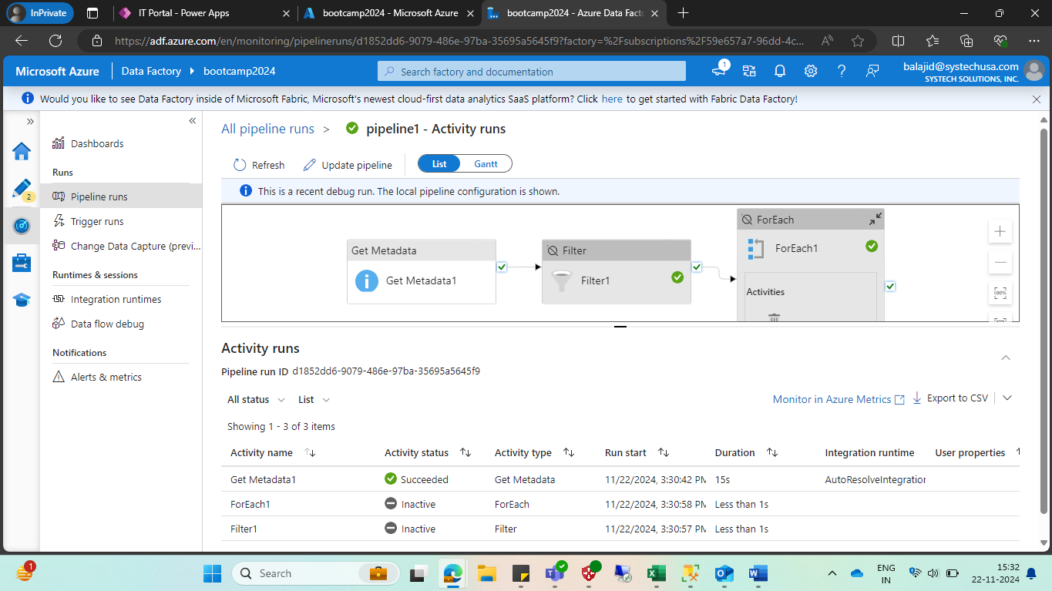
- Testing Document – UnitTesting_Practice_EmpId
- DDLs for Target Table
- Sample Output of Target table Screenshot
- TargetTable Name – Dim_TableName_EmpId, Fact_TableName_EmpId

